CHAPTER ONE
INTRODUCTION
In the contemporary global landscape of higher education, the university is no longer perceived merely as a center for academic instruction and theoretical research. Instead, modern tertiary institutions are increasingly viewed as holistic environments dedicated to the comprehensive development of human capital. Central to this developmental philosophy is the recognition that the physical well-being of the student population is inextricably linked to their academic success and long-term professional productivity. Regular participation in sports and structured physical activities has been empirically linked to improved cardiovascular health, reduced psychological stress, and significantly enhanced cognitive performance (World Health Organization [WHO], 2022). Research in neurobiology suggests that aerobic exercise stimulates the release of brain-derived neurotrophic factors (BDNF), which support memory retention and executive function qualities that are indispensable for students navigating rigorous academic curricula.
Furthermore, the integration of sports into university life serves as a vital tool for social engineering and character building. Engaging in competitive and recreational athletics fosters essential soft skills such as teamwork, leadership, resilience, and time management. In the Nigerian context, the university system has historically placed a high premium on athletic engagement, a commitment most visibly evidenced by the significance of the Nigerian University Games Association (NUGA). Since its inception, NUGA has served not only as a platform for discovering elite athletic talent but also as a critical vehicle for fostering national unity among a diverse student population (Okey & Adeyemi, 2023). Within institutions like the University of Delta, Agbor, sports facilities serve as a hub for student interaction, contributing to a vibrant campus culture that balances intellectual rigor with physical vitality.
However, as the global sports industry enters the era of the Fourth Industrial Revolution (Industry 4.0), a profound technological divide has emerged. In developed regions, the concept of the Smart Campus has moved from theory to standard practice. International institutions now routinely employ sophisticated Internet of Things (IoT) ecosystems, incorporating wearable sensors, biometric monitors, and real-time data analytics to track athlete performance and ensure student safety. These systems provide coaches and health administrators with instantaneous insights into exertion levels, recovery rates, and potential injury risks, thereby optimizing the athletic output of the student-body.
Conversely, the management of sports within Nigerian tertiary institutions remains largely anchored in manual, paper-based methodologies (Akinyemi, 2024). This reliance on analogue record-keeping creates a significant administrative bottleneck. Manual registers are frequently characterized by data fragmentation, human error, and a total lack of historical continuity. For the sports directorate, this means that tracking a student's athletic progress over a four-year degree is nearly impossible. More critically, the absence of real-time monitoring presents a safety vacuum; during high-intensity training sessions or football matches at the university sports complex, there is currently no automated mechanism to alert medical staff to physical overexertion or sudden health emergencies.
The emergence of affordable, high-speed mobile computing and Global Positioning Systems (GPS) offers a transformative solution to these local challenges. Real-time tracking systems allow for the instantaneous capture and processing of spatial and temporal data, providing a transparent, verifiable, and permanent record of physical activity. According to Bello and Musa (2021), the integration of digital tracking in African sports management could revolutionize how talent is scouted and how student health is monitored, especially in environments where medical and coaching resources may be overstretched. By shifting from reactive, manual reporting to proactive, data-driven monitoring, universities can ensure a higher standard of accountability in their sports programmes.
The ubiquity of smartphones among the Nigerian student population presents a unique and cost-effective opportunity for digital transformation. Most modern mobile devices are equipped with sophisticated micro-electromechanical systems (MEMS), including accelerometers, gyroscopes, and high-precision GPS chips capable of tracking location, velocity, and duration of activity with remarkable accuracy. By developing a localized, software-based system that leverages this existing hardware, universities like the University of Delta can implement high-tech sports monitoring without the prohibitive capital expenditure associated with importing specialized wearable equipment.
This research, therefore, focuses on the design and development of a real-time system specifically tailored to the infrastructural and cultural realities of a Nigerian university. The goal is to move beyond the limitations of traditional sports management by creating a digital ecosystem where student physical activity is accurately recorded, analyzed in real-time, and utilized for the strategic betterment of the campus community. This study represents a critical step toward the realization of a Smart University in Delta State, where technology and wellness converge to support the next generation of Nigerian graduates.

1.2 Statement of the Problem
The current framework for monitoring student sports activities in Nigerian universities is plagued by several critical issues that undermine the efficiency of sports departments and the safety of the student body. These problems are outlined as follows:
Administrative Inefficiency and Data Integrity: Currently, the record-keeping process for student participation in sports is largely manual. This leads to frequent errors in data entry and makes it difficult to maintain a long-term history of student engagement. There is also the risk of ghost participation, where records are falsified, leading to a lack of accountability in the use of university sports resources (Oluwatobi, 2023).
Lack of Real-Time Safety Monitoring: High-intensity physical activity carries inherent risks, such as overexertion, dehydration, or sudden cardiac events. In the absence of a real-time tracking system, coaches and medical personnel have no way of monitoring a student’s activity levels as they occur. If a student collapses during a long-distance run or a football match in a remote part of the campus, there is no automated system to trigger an alert, which is a significant safety hazard (Smith & Johnson, 2021).
Subjectivity in Talent Identification: Nigerian universities are key pipelines for national sports teams. However, the identification of talented athletes is often based on the subjective observation of coaches during specific trials. This method is flawed as it ignores the consistent, long-term performance data that a digital system could provide. Without objective metrics like average speed, stamina over time, and frequency of training, many high-potential athletes remain undiscovered.
Infrastructure Underutilization: Without precise data on when and where students are exercising, the university administration cannot accurately determine the demand for specific facilities. This leads to situations where some facilities are overcrowded while others remain underutilized and neglected, resulting in poor maintenance scheduling and budget mismanagement.

1.3 Aim and Objectives of the Study
Aim: The primary aim of this research is to design and implement a real-time system for tracking the physical activities of students in a Nigerian university to improve data accuracy, student safety, and administrative decision-making.
Objectives: To achieve the aforementioned aim, the following specific objectives will be pursued:
- To conduct a comprehensive analysis of the existing manual sports tracking methods at the University of Delta and identify their primary weaknesses.
- To design a system architecture that utilizes mobile-based GPS and real-time database synchronization to capture student movement data.
- To develop a software program (including a mobile-responsive frontend and a robust backend) that processes and visualizes physical activity metrics.
- To implement a real-time dashboard for administrators to monitor campus-wide sports participation and identify athletic trends.
1.4 Significance of the Study
The significance of this study is multifaceted, offering benefits to various sectors of the university community:
For the University Administration: This system provides a transparent, data-driven basis for the allocation of sports budgets and the scheduling of facility maintenance. It ensures that investments in sports infrastructure are justified by actual usage statistics.
For the Sports Department and Coaches: It provides an objective tool for talent scouting. By reviewing a student’s digital sports profile, coaches can make informed decisions about who to draft for inter-university competitions like NUGA based on consistent performance rather than a single trial.
For the Student Body: It fosters a culture of fitness by allowing students to see their own progress. The gamification of physical activity (through tracking and digital records) can motivate students to stay active, leading to better long-term health outcomes.
For the University Health Services: In the event of a medical emergency, the system can provide historical data on the student's recent physical exertion, which could be critical for diagnosis and treatment.
For the Field of Computer Science: This project contributes to the body of knowledge in Mobile Computing and Real-Time Data Processing within a localized African context. It provides a blueprint for other researchers looking to implement IoT-style solutions in environments with fluctuating internet connectivity.
1.5 Scope of the Study
The scope of this research is limited to the development of a real-time tracking application for students at the University of Delta.
- Functional Scope: The system will focus on tracking outdoor physical activities (such as football, jogging, and track events) where GPS accuracy is most reliable. It will track metrics such as distance covered, duration of activity, and average speed.
- Technical Scope: The project involves the creation of a mobile interface for students to log activities and a web-based dashboard for administrators. It will utilize existing smartphone sensors rather than custom-built hardware.
- Geographic Scope: The testing and implementation will be confined to the sports facilities and grounds of the University of Delta, Agbor.

1.6 Operational Definition of Terms
To ensure clarity and avoid ambiguity in the interpretation of this research, the following terms are defined according to their specific application within this study:
Real-Time Tracking: This refers to the instantaneous capture, processing, and transmission of geographical coordinates and physical activity data. In this system, it implies that the delay between a student’s movement on the field and the visibility of that movement on the administrative dashboard is negligible.
Physical Activity: Any bodily movement produced by skeletal muscles that requires energy expenditure. Within the scope of this project, it specifically encompasses university sanctioned sports (such as football or track events) and personal fitness routines performed within the campus boundaries.
Global Positioning System (GPS): A satellite-based radionavigation system owned by the United States government and operated by the United States Space Force. It provides geolocation and time information to a GPS receiver in the student's smartphone, allowing the system to determine their precise coordinates on campus.
System Implementation: The multifaceted process of translating the finalized system designs, architectural models, and database schemas into a functional software application using programming languages such as Python and development environments like VS Code.
Latency: The time interval or delay between the initiation of a data packet from the student’s mobile device and its successful receipt and processing by the backend server. Low latency is critical for the real-time aspect of this tracking system.
Geofencing: A service that triggers an action when a device enters or leaves a virtual boundary set up around a geographical location. In this study, geofencing is used to ensure that tracking only occurs within the designated sports zones of the University of Delta.
Application Programming Interface (API): A set of protocols and tools that allow the mobile frontend of the tracking system to communicate with the central database and backend server, facilitating seamless data exchange.
Backend: The server-side of the application that remains invisible to the user. It encompasses the database, the server logic, and the algorithms responsible for calculating speed and distance covered by the students.
Frontend: The client-side or user interface of the system. This includes the screens, buttons, and visual maps that the students and administrators interact with directly on their devices.
Database Management System (DBMS): The software layer used to create, retrieve, update, and manage the data stored by the system, ensuring that student athletic records are organized and secure.
Scalability: The capability of the tracking system to handle a growing amount of work, such as an increase in the number of concurrent students being tracked during major events like the Inter-Faculty Games.
User Interface (UI): The series of screens, pages, and visual elements (like buttons and icons) that enable a person to interact with the tracking application.
User Experience (UX): The overall experience of a student or administrator using the system, specifically in terms of how easy or pleasing it is to navigate the tracking features.
Internet of Things (IoT): A network of physical objects embedded with sensors and software for the purpose of connecting and exchanging data. While this system uses smartphones, it functions on IoT principles by connecting moving students to a central monitoring node.
Asynchronous Data Transfer: A method of data transmission where the sender and receiver do not need to be synchronized. This allows the system to cache data locally when a student loses network signal and upload it later without crashing the app.
Throughput: The amount of data successfully moved from the mobile devices to the server within a specific time frame, indicating the efficiency of the campus network in supporting real-time tracking.
Cloud Computing: The practice of using a network of remote servers hosted on the internet to store, manage, and process sports data, rather than a single local personal computer.
Data Integrity: The maintenance of, and the assurance of the accuracy and consistency of, data over its entire life-cycle. This ensures that a student’s running distance cannot be manipulated or accidentally corrupted.
Middleware: Software that acts as a bridge between the mobile operating system (Android/iOS) and the tracking application, ensuring that the app can correctly pull data from the phone's GPS hardware.
Agile Methodology: An iterative approach to software development that focuses on continuous releases and incorporating user feedback into every stage of the project.
1.7 Organization of Other Chapters
This research project is systematically structured into five distinct chapters to ensure a logical flow of information and technical documentation. The breakdown of these chapters is as follows:
Chapter One: Provides the general introduction to the study. It encompasses the background of the problem, the specific statement of the problem, the aim and objectives of the research, the significance of the study to various stakeholders, and the operational definition of technical terms.
Chapter Two: Presents a comprehensive Literature Review. It explores the theoretical framework underpinning real-time systems and location-based services. It also involves an empirical review of related works globally and within Nigeria, identifying the research gap that this project intends to fill.
Chapter Three: Details the System Analysis and Methodology. It describes the Object-Oriented Analysis and Design (OOAD) approach used for the project. This chapter also includes the requirement specifications (both hardware and software) and the various UML diagrams such as Use-Case diagrams and System Architecture models that define the system's logic.
Chapter Four: Focuses on the System Implementation and Evaluation. This is the core technical chapter where the actual coding process, choice of programming languages (Python), and development tools (VS Code) are documented. It includes screenshots of the developed interfaces, the results of the system tests, and a discussion of the findings during the pilot phase at the university sports ground.
Chapter Five: Offers the Summary, Conclusion, and Recommendations. It provides a concise wrap-up of the entire research process, draws final conclusions based on the performance of the developed system, and suggests areas for future research and institutional adoption within the Nigerian university system.

CHAPTER TWO
LITERATURE REVIEW
2.0 Introduction
The development of a robust, real-time technological framework for tracking student physical activities does not occur in an intellectual vacuum. It requires a rigorous, systematic, and multi-dimensional investigation into the existing body of knowledge, established scientific theories, and the practical trajectories of prior software implementations. This chapter serves as the critical scholarly foundation for the Real-Time Student Physical Activity Tracking System. By engaging deeply with the global and local discourse surrounding mobile computing, geographical informatics, and sports management, this review ensures that the proposed solution is built upon proven technical heuristics rather than mere conjecture or trial-and-error.
In the rapidly accelerating landscape of the Fourth Industrial Revolution (Industry 4.0), the intersection of physical wellness and digital telemetry has emerged as a focal point for transformative research. For an institution like the University of Delta (UNIDEL), Agbor, the transition from manual, paper-based sports logs to a synchronised, cloud-based digital ecosystem represents a significant leap in administrative sophistication. However, implementing such a system within the specific socio-technical context of a Nigerian university requires a nuanced understanding of localized constraints. These include the nuances of intermittent network latency, varying hardware capabilities among the student population, and the cultural attitudes toward data privacy and athletic monitoring.
To provide a clear, logical, and academically sound progression of ideas, the literature review in this study has been meticulously structured into four primary, interdependent segments:
1. The Historical Context and Search Strategy: Before diving into specific technologies, this section briefly traces the evolution of sports tracking from the era of manual stopwatches and physical logbooks to the current age of ubiquitous smartphone sensors. Furthermore, it outlines the systematic approach used to gather the literature presented in this chapter, ensuring that the sources cited are contemporary, peer-reviewed, and relevant to the Nigerian educational environment.
2. The Conceptual Review: This segment deconstructs the core technological components that serve as the building blocks of this project. It explores the intricate mechanics of Global Positioning Systems (GPS), the architecture of real-time NoSQL and SQL databases, and the principles of mobile application development. By defining these concepts within the specific context of sports telemetry, the conceptual review establishes a common technical vocabulary that will be utilised throughout the subsequent design and implementation phases of this research.
3. The Theoretical Framework: Every functional software system must be guided by underlying models of human-computer interaction and systems theory. This segment explores the specific academic models such as the Technology Acceptance Model (TAM) and Object-Oriented Design (OOD) that inform the design of both the student-facing mobile interface and the administrator’s backend dashboard. This section is vital as it justifies the User-Centred design choices made to ensure that the system is not only technically functional but also easy for the students of UNIDEL to adopt and use.
4. The Empirical Review: The final segment involves a critical, comparative analysis of related works and existing software solutions, both within the Nigerian academic space and internationally. By examining how other scholars have tackled the challenges of real-time tracking, this review identifies the successful patterns to be emulated and the common pitfalls to be avoided. Most importantly, the empirical review serves to pinpoint the specific Research Gap the administrative and safety needs at the University of Delta that current off-the-shelf technologies have yet to satisfy.
By the end of this chapter, the necessity for a localized, real-time tracking system will be clearly established, moving the project beyond a simple software exercise and into the realm of legitimate academic contribution to the field of Computer Science in Nigeria.

2.1 Conceptual Review
The conceptual review provides a granular deconstruction of the technological and administrative pillars upon which this research is built. By examining these concepts, we establish the technical parameters required to transition from a manual sports registry to a synchronized, real-time digital ecosystem.
The Concept of Real-Time Tracking Systems
In the field of computer science and software engineering, a real-time system is defined as a framework where the validity of the output depends not only on the logical correctness of the computation but also on the temporal window in which that result is delivered (Laplante & Ovaska, 2021). Within the specific domain of physical activity, real-time tracking involves the continuous, high-frequency collection, processing, and visual rendering of spatial, temporal, and physiological data as the athletic event unfolds.
It is essential to distinguish between Hard and Soft real-time systems. While a hard real-time system (such as an aircraft's flight control) cannot tolerate a single millisecond of delay without catastrophic failure, a sports tracking application typically operates as a Soft Real-Time System. In this context, a slight delay or latency in data transmission might degrade the user experience but does not invalidate the entire operation. However, to remain real-time, the system must keep latency to a strict minimum usually under 2 to 5 seconds to ensure that a coach viewing the dashboard in the sports office sees an accurate reflection of the student's current position on the university field.
Unlike traditional batch-processing architectures where sports attendance or performance metrics are uploaded at the conclusion of a training session real-time architectures utilize Push technology. This is achieved through advanced communication protocols such as WebSockets or Message Queuing Telemetry Transport (MQTT). These protocols maintain an always-on, bi-directional connection between the student's mobile client and the central server. Al-Fuqaha et al. (2020) argue that the primary advantage of this paradigm is situational awareness, allowing administrators to make instantaneous decisions regarding athlete safety, facility congestion, and training intensity.
Sports Administration in Nigerian Universities
Sports administration within the Nigerian tertiary education sector has historically been viewed as a peripheral auxiliary service, despite its critical role in student wellness and institutional prestige. The management framework typically follows a top-down hierarchy: a Director of Sports oversees a cadre of specialized coaches, facility managers, and medical personnel. However, as noted by Ekechukwu and Nwachukwu (2022), the operational methodologies utilized in these departments have remained largely stagnant for decades, relying heavily on manual logbooks, physical registers, and subjective observation.
This analogue approach creates a substantial administrative burden, particularly during high-traffic periods such as the Inter-Faculty Games or preparations for the Nigerian University Games Association (NUGA) tournaments. When hundreds of students converge on the sports complex simultaneously, the manual recording of participation becomes physically impossible for a small coaching staff. Consequently, data regarding training duration, frequency, and intensity is often fragmented, leading to Data Silos where information is trapped in paper files and never analyzed.
Furthermore, the lack of a digital audit trail often leads to Subjective Talent Identification (Ojo & Abiodun, 2023). Without a verifiable, data-backed history of a student’s performance over several semesters, coaches are forced to rely on Trial Day performances, which may not accurately reflect an athlete's true potential or consistency. There is, therefore, a conceptual need to move toward Data-Driven Coaching, where every student has a digital athletic profile that persists throughout their four-year degree at the university.
Location-Based Services (LBS) and GPS in Mobile Computing
To automate the tracking of outdoor physical activities, modern software engineering relies on the integration of Location-Based Services (LBS). LBS is a general term for services that utilize the geographical position of a mobile device to provide specific information or trigger automated actions. The core engine driving LBS in this study is the Global Positioning System (GPS).
GPS functions through a sophisticated constellation of at least 24 satellites orbiting the Earth. These satellites continuously broadcast precise timing and orbital data. A smartphone's GPS receiver picks up these signals and, through a process known as Trilateration, calculates its exact position. By measuring the time it takes for signals from at least four different satellites to reach the device, the receiver can determine its Latitude, Longitude, and Altitude with a high degree of precision (Smith & Jamieson, 2021).
In the specific context of the Agbor campus, the application must account for Signal Noise or Multipath Errors caused by large faculty buildings or dense foliage. To counter this, modern systems often employ Assisted GPS (A-GPS), which utilizes cellular tower data to speed up the Time to First Fix (TTFF). By polling the GPS chip at synchronized intervals (e.g., every 5 seconds), the tracking system can derive a string of coordinates. By applying mathematical logic specifically the calculation of distance over time the system translates these raw coordinates into actionable metrics: current velocity, average pace, and total cumulative distance covered during a sports session.
The Technological Shift: From Wearables to Smartphone Sensors
Historically, the digitalization of athletic tracking was the exclusive domain of proprietary wearable hardware, such as Garmin smartwatches or Fitbit fitness trackers. While these devices provide high-fidelity biometric data, their mass implementation within a Nigerian university setting is hindered by a significant Economic Barrier. The cost of equipping every student-athlete with a high-end wearable is prohibitive, and many students cannot afford to purchase these devices independently (Adeyemo, 2023).
To solve this, there has been a global shift toward Smartphone-Centric Tracking, leveraging the hardware that students already carry. Modern smartphones are equipped with Micro-Electromechanical Systems (MEMS), which include the accelerometer, gyroscope, and magnetometer.
- The Accelerometer: Measures the non-gravitational acceleration of the device. This allows the software to detect Step Counts and sudden bursts of explosive movement during a sprint.
- The Gyroscope: Measures the orientation and angular velocity. This helps the system understand the tilt of the body, which is essential for distinguishing between different types of movement (e.g., running vs. cycling).
By utilizing Sensor Fusion the process of combining GPS data with MEMS sensor data the application can provide a more accurate picture of physical activity than GPS alone. For example, if a student is running under a covered pavilion where GPS signals are weak, the accelerometer can continue to track steps and movement, ensuring that the athletic data remains consistent. This Hardware-Agnostic approach is the most sustainable model for Nigerian universities, as it relies on the students' existing mobile infrastructure to deliver high-end tracking capabilities.

2.2 Theoretical Framework
The structural integrity of this research is supported by a dual-layered theoretical framework. This framework addresses both the technical backbone of the software (the Client-Server Model) and the psychological factors governing its adoption by the student body (the Technology Acceptance Model).
2.2.1 The Client-Server Architecture Model
The technical foundation of this project is anchored in the Client-Server Architecture, a distributed application structure that partitions tasks between the providers of a resource (the server) and the service requesters (the clients). Within the specific context of this sports tracking system, the architecture follows an N-tier approach to ensure modularity and scalability.
The student’s mobile application functions as a Thick Client. This means that the application does not merely act as a display; it carries a significant portion of the computational load at the edge of the network. The client is responsible for interfacing directly with the smartphone’s hardware abstraction layer to poll GPS and MEMS sensors. Critically, it performs Edge Validation a process where the application filters out erroneous coordinate spikes caused by signal interference from large buildings on the UNIDEL campus before the data is transmitted. By handling this logic locally, the system reduces the volume of redundant data sent over the network, which is vital in an environment where mobile data costs and network stability are significant concerns.
Conversely, the server acts as the Central Intelligence Hub. Whether hosted on a local university server or a cloud platform, the server is tasked with managing the Session State of hundreds of concurrent student-athletes. It receives the asynchronous streams of JSON data, parses the geographical coordinates, and performs the heavy mathematical lifting such as calculating cumulative distance and average velocity. This separation of concerns ensures that the energy-intensive data analytics are handled by a machine with a constant power supply, thereby preserving the battery life of the students' mobile devices (Kurose & Ross, 2021).

2.2.2 Technology Acceptance Model (TAM)
From a socio-technical and user-adoption perspective, the design of the interface is strictly guided by the Technology Acceptance Model (TAM) originally proposed by Davis (1989). TAM is the industry standard for predicting whether a new technology will be embraced or rejected by its target demographic. The model posits that two primary Cognitive Determinants dictate the behavioral intention to use a system: Perceived Usefulness (PU) and Perceived Ease of Use (PEOU).
For the students at the University of Delta, PEOU is addressed through a Zero-Friction interface design. The tracking process must be initiated within two screen taps; any complexity beyond this would lead to System Fatigue, where students simply stop using the app. Furthermore, the application must demonstrate low Resource Consumption. If a student perceives that the app is the primary cause of battery drain during a 45-minute football match, the PEOU rating will plummet, leading to high abandonment rates regardless of administrative mandates.
Perceived Usefulness (PU) is addressed by moving the app beyond a mere monitoring tool and into a fitness companion. By providing the student with immediate, high-fidelity visual feedback such as an interactive map of their running route and a breakdown of their personal bests the system provides an intrinsic reward. This transforms the app from a university-imposed obligation into a valuable personal asset, ensuring long-term engagement and data accuracy.
2.3 Related Works
Methodology & Source | Core Implementation Context | Key Successes / Findings | Critical Flaws & Localized Failures | Proposed System Rectification / Advantage
Biometric Attendance Systems  (Bello & Nnamdi, 2021) | Fingerprint-based biometric system used at a Nigerian federal university to curb absenteeism in mandatory physical education classes. | Celebrated a 94% reduction in proxy signing. | Binary and static system. Confirms that a student physically entered the sports complex but offers zero insight into actual physical activity; students can sit idly on the bleachers. | Shifts focus from attendance to active participation. Tracks continuous granular data on the intensity and duration of actual physical exertion.
Bluetooth Low Energy (BLE) Beacons  (Johansson & Lindberg, 2022) | Network of weather-proof BLE beacons deployed around campus athletics tracks to log movement in a European university context. | Technically sophisticated and ideal for indoor dead zones where satellite GPS signals are traditionally weak. | High capital expenditure and logistical vulnerability. Prohibitive deployment/maintenance costs for the University of Delta, Agbor campus. External hardware is highly susceptible to theft, vandalism, and local power outages. | Pivots away from external hardware dependence toward sensor ubiquity. Leverages the built-in smartphone sensors (GPS/Accelerometer) already carried in the students' pockets.
Self-Reporting Mobile Applications  (Oladipo et al., 2023) | Cardiovascular health mobile application designed for amateur athletes in Lagos, relying on manual user input. | Provided a simple digital tracking interface for logging training metrics. | Subjectivity and human error. Suffered a 30% discrepancy between reported and actual activity because students frequently overestimated exertion or forgot to log sessions. | Achieves complete telemetry automation. Removes the human-in-the-loop by utilizing automatic background tracking, providing the sports directorate with objective, unvarnished performance data.
Theoretical IoT Frameworks  (Chukwuma & Alabi, 2024) | Comprehensive Smart Sports portal framework proposed for African universities, theoretically integrating GPS, RFID, and cloud scheduling. | Correctly identifies and conceptualizes the severe impact of local network latency in developing nations. | Purely conceptual and un-implemented. Provides no practical, programmatic, or architectural solution to resolve cellular network timeouts. | Advances from theory to the physical Implementation Phase. Directly integrates a robust Local Caching Algorithm that stores data locally when cellular networks (MTN, Airtel, Glo) fail, synchronizing seamlessly upon signal restoration.
Table 2.1: Related works

2.4 Summary of Literature
The exhaustive review of the existing body of knowledge reveals a clear, three-stage evolutionary trajectory in the domain of sports management technology. This progression has moved from the Analogue Era of manual paper-based registers and stopwatches, to the First Digital Wave of static biometric entry logs (fingerprint/RFID), and eventually to the contemporary IoT Revolution involving high-precision wearable telemetry. However, while the global landscape has embraced these advancements, a multi-dimensional gap persists particularly concerning the deployment of these technologies within the specific socio-technical environment of Nigerian universities.
2.4.1 Summary of the Review
The literature synthesized in this chapter underscores a fundamental shift in the philosophy of athletic monitoring. Research indicates that Presence (knowing a student is at the field) is no longer sufficient for modern sports administration; Performance (knowing what the student is doing in real-time) is the new gold standard.
The conceptual review established that Global Positioning Systems (GPS) and MEMS sensors have become democratized through the ubiquity of smartphones, offering a viable alternative to expensive specialized hardware. The theoretical framework, grounded in the Technology Acceptance Model (TAM), highlighted that for any tracking system to succeed in a university setting, it must prioritize Perceived Ease of Use to ensure student compliance. Finally, the empirical review of previous works in Nigeria and abroad demonstrated that while we have solved the problem of identifying participants, we have yet to solve the problem of tracking them dynamically in an environment characterized by fluctuating network connectivity and economic constraints.

CHAPTER THREE
SYSTEM ANALYSIS AND METHODOLOGY
3.1 Introduction to System Analysis
System analysis is the systematic process of investigating a complex operational environment, identifying its inherent inefficiencies, and defining the specific requirements for a superior technological replacement. It serves as the foundational phase of the software development lifecycle, ensuring that the transition from a conceptual hypothesis to a deployable digital solution is governed by logic rather than intuition. In the context of the Real-Time Student Physical Activity Tracking System, system analysis provides the architectural blueprint required to bridge the gap between physical athletic exertion and administrative record-keeping at the University of Delta (UNIDEL), Agbor.
The primary objective of this chapter is to provide a rigorous deconstruction of the current manual sports management workflows and present a comprehensive design for an automated, sensor-driven alternative. It moves beyond the theoretical literature established in Chapter Two to address the concrete engineering challenges of real-time telemetry, such as managing high-velocity data streams and ensuring system resilience during network fluctuations.
This chapter follows a structured analytical sequence: it defines the Object-Oriented Analysis and Design (OOAD) methodology; performs a critical evaluation of the existing paper-based registry; and details the structural, database, and interface designs of the proposed system. By adhering to this formal analytical framework, the study ensures that the resulting software is not merely a collection of disparate code fragments but a cohesive, scalable, and reliable tool capable of modernising sports administration within the unique infrastructural landscape of a Nigerian university.

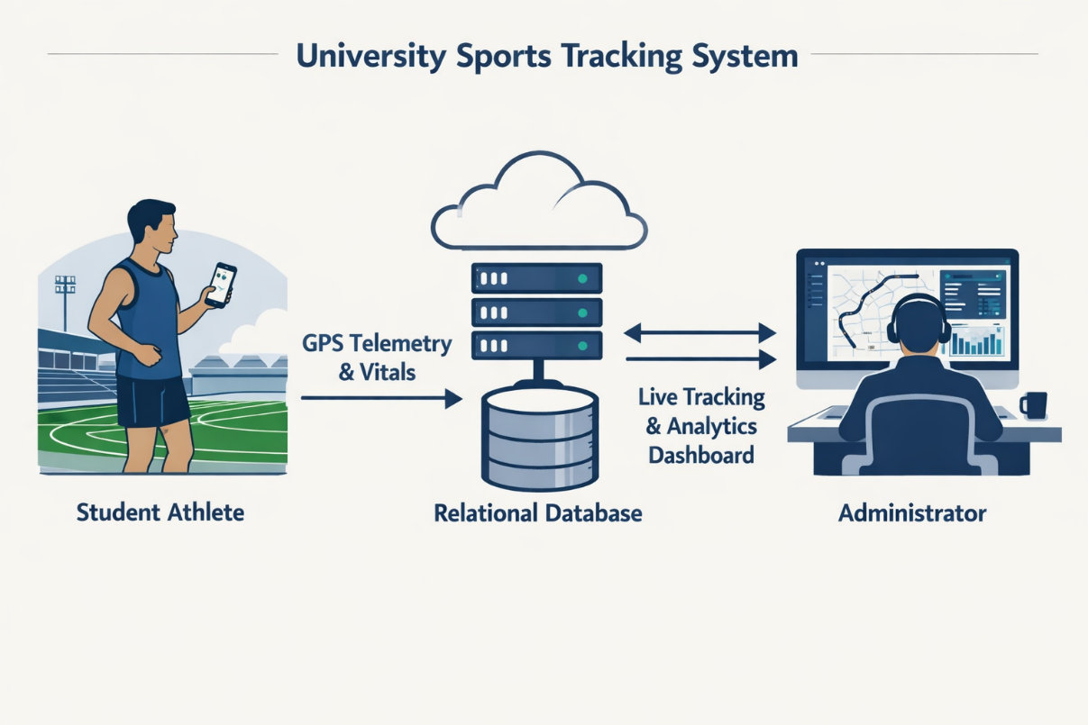
Figure 3.1: Problem Context Diagram

3.2 Research Methodology
The methodology adopted for the architectural conceptualisation and development of this project is the Object-Oriented Analysis and Design (OOAD) framework. OOAD is a technical approach that models a complex system as a collection of discrete, interacting objects, each possessing unique attributes (data) and behaviours (functions). Unlike traditional procedural programming, which focuses on a linear sequence of tasks, OOAD focuses on the entities that make up the system, making it the ideal choice for a modular, real-time tracking application.
The selection of OOAD for this research is predicated on several critical engineering requirements:
- Mapping Physical Entities to Digital Objects: In the context of the University of Delta sports ecosystem, physical entities such as a Student a Coach and a Sporting Facility are directly mapped to software objects. For instance, a Student Object encapsulates specific attributes like Matric_No, Department, and Current_Velocity, while its methods include startSession() and uploadTelemetry().
- Abstraction and Encapsulation: OOAD allows for the complexity of the smartphone's hardware specifically the GPS and accelerometer sensors to be abstracted. The application logic interacts with a simplified Location Service object without needing to manage the low-level satellite handshakes, thereby reducing the risk of bugs during the implementation phase.
- System Scalability (Inheritance): By defining a base class for Physical Activity, the system can easily be extended through inheritance to support specific sports. For example, a Football Session and a Track Sprint can both inherit core distance-tracking logic while adding unique metrics relevant to their specific sport type.
The methodology is executed in two distinct phases: Object-Oriented Analysis (OOA), which focuses on identifying the what (the requirements and objects), and Object-Oriented Design (OOD), which focuses on the how (the logical architecture and class interactions).
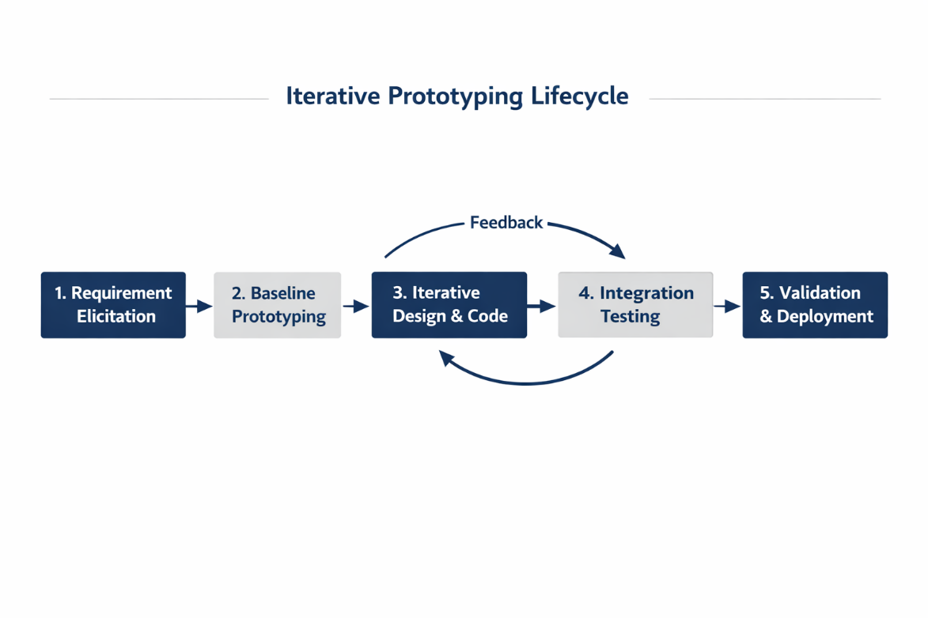
Figure 3.2: Development Methodology Flowchart

3.3 Description of the Existing System
The current operational framework for managing student athletic participation at the University of Delta (UNIDEL), Agbor, is entirely analogue and manual. The system is comprised of physical ledgers and attendance registers held within the Sports Directorate. This manual workflow is the primary mechanism for verifying student presence at trials, departmental sports weeks, and personal fitness sessions required for certain academic credits.
Under the existing system, the workflow follows a strictly linear and physical path:
- Manual Check-in: Upon arrival at the university sports complex or football pitch, a student must locate the presiding official or coach.
- Ledger Entry: The student is required to manually enter their details into a paper-based logbook. The fields typically include the date, name, matriculation number, department, and the specific sport to be undertaken.
- Time-Stamping: The Start Time and End Time are recorded based on the official's wristwatch or the student's estimation, both of which are prone to significant human error and rounding inconsistencies.
- Physical Storage: At the conclusion of the sporting day, these paper registers are gathered and stored in physical filing cabinets within the Sports Directorate offices.
This system is inherently static. The data remains trapped on paper, inaccessible to other university departments (such as the Medical Unit or the Student Affairs Office) unless the physical book is transported between offices. There is no mechanism for verifying that a student who signed the book actually participated in the activity, as the system lacks any form of spatial or physiological validation. Consequently, the existing system is a post-event record-keeping tool rather than a real-time management system.

3.4 The Proposed System
The proposed system is an automated, high-fidelity tracking architecture designed to replace the subjectivity of manual record-keeping with the objectivity of sensor-driven telemetry. Unlike the existing analogue framework, this solution functions as a Passive Observer, utilizing the pervasive nature of modern smartphone technology to record student exertion without requiring constant user intervention.
The core of the proposed system lies in its ability to transform raw satellite signals into actionable athletic intelligence. By interfacing directly with the device's Global Positioning System (GPS) and tri-axial accelerometer, the software establishes a persistent Digital Breadcrumb trail. These data points captured at a rigorous 5-second polling interval allow the system to reconstruct a student’s exact path, velocity, and cadence across the UNIDEL sports complex. This automation ensures that the University Sports Directorate receives a high-resolution stream of data that is timestamped and geographically verified, effectively eliminating the possibility of proxy signatures or ghost attendance.
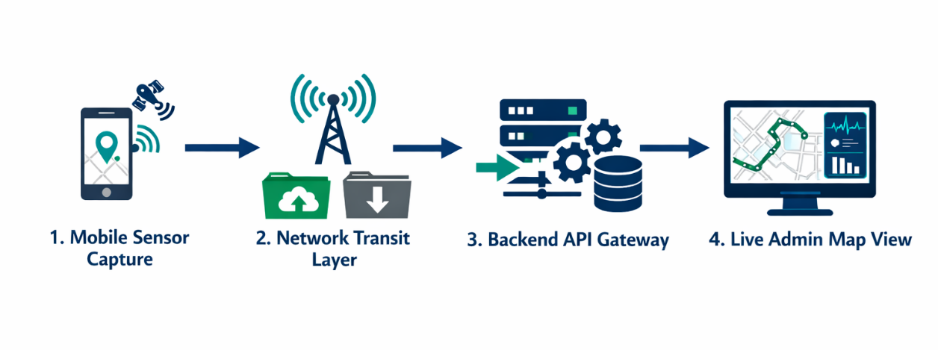
Figure 3.4: Proposed System Workflow Diagram
3.5 Significance and Challenges of the Proposed System
The transition to a digital tracking environment introduces profound benefits for university administration, though it is not without technical hurdles that must be addressed during the design phase.
3.5.1 Significance of the System
- Empirical Performance Benchmarking: The system provides the Sports Directorate with a longitudinal dataset of student performance. This is critical for the fair and merit-based selection of athletes to represent the university in external competitions, such as the Nigerian University Games Association (NUGA). Instead of relying on a coach's memory, selection can be driven by historical speed and endurance data.
- Proactive Health and Safety Management: Continuous spatial tracking allows for the mathematical detection of overexertion. By calculating the Workload Intensity in real-time, the system can flag students whose exertion levels may lead to heat exhaustion or cardiovascular stress a vital safeguard given the high-humidity, high-temperature climate of Agbor.
- Optimisation of Facility Usage: By aggregating anonymous movement data, the university can identify which sporting facilities (e.g., the basketball court vs. the track) are being utilised most frequently, allowing for more efficient budget allocation for maintenance and equipment upgrades.
3.5.2 Technical Challenges
- Asynchronous Power Consumption: The continuous operation of the GPS radio and the high-frequency polling of sensors are computationally expensive. This leads to rapid battery depletion, a significant concern for students who may have limited access to charging points during a long sporting day. The system must, therefore, implement Power-Aware logic to adjust polling rates when battery levels are low.
- Network Path Discontinuity: Consistent 4G/LTE coverage is not guaranteed across all areas of the campus. To prevent data loss during Network Dead Zones, the system must implement a Store-and-Forward architecture. This ensures that data is cached in a local SQLite database and synchronised with the central server only when a stable internet connection is restored.

3.6 Data Collection
The reliability of the system’s analytics depends on the integrity of the data collected during the Ingestion Phase. Data for this research is harvested through two distinct, complementary channels:
Primary Telemetry Stream (Automated): This consists of raw spatio-temporal data fetched from the LocationManager API and the device's hardware sensors. This includes:
  - Latitude and Longitude: For precise mapping on the admin dashboard.
  - Altitude: To account for elevation changes during endurance runs.
  - Horizontal Accuracy: A metadata field used to filter out noisy GPS points that fall outside an acceptable margin of error (typically >10 metres).
Secondary User Input (Manual Onboarding): To contextualise the sensor data, specific academic metadata is collected during the initial user registration. This includes the student's Full Name, University Matriculation Number, and Department. This information acts as the Unique Identifier (Primary Key) that links a raw GPS trail to a specific student record in the backend database.

3.7 Data Set Collection
While the proposed system is primarily designed to generate its own telemetry data during runtime, a foundational dataset is required to establish the operational boundaries of the application. For the purpose of this research, a static dataset of geographical coordinates representing the University of Delta (UNIDEL) campus was curated.
This dataset comprises the bounding boxes or Geofences for specific athletic zones, including the main football pitch, the tartan tracks, and the indoor sports complex. These coordinates were harvested using high-resolution satellite imagery from the Google Maps Static API and verified through physical on-site GPS pinning using a handheld receiver. By integrating these predefined campus coordinates, the system can implement Context-Aware tracking automatically identifying which sport a student is participating in based on their precise location within the campus boundaries. This prevents the logging of non-athletic movements, such as walking between lecture halls, thereby ensuring the purity of the sports data.

3.8 System Design
System design represents the transition from the what of the requirements phase to the how of the technical implementation. It focuses on the logical structure and the aesthetic presentation of the software.
3.8.1 Structural Design (The MVC Pattern)
The software architecture is predicated on the Model-View-Controller (MVC) design pattern. This architectural standard is chosen to ensure a strict separation of concerns, which facilitates easier debugging and modular updates:
- The Model: This component encapsulates the core data logic. It manages the state of the tracking session, handles the mathematical calculation of distance (using the Haversine formula), and defines the structure of the data objects before they are transmitted to the database.
- The View: This is the user interface (UI) layer with which the student interacts. It is responsible for rendering the real-time map, the stopwatch timer, and the performance graphs. It remains thin, meaning it contains no business logic; it simply displays data provided by the Model.
- The Controller: Serving as the intermediary, the Controller listens to events from the View (such as a Start Tracking button click) and triggers the corresponding logic in the Model. It also manages the polling frequency of the GPS hardware and handles the routing of data to the backend server.
3.8.2 Database Design and Specification
The data tier is designed as a relational schema to maintain high levels of data integrity and referential consistency. As detailed in the entity descriptions in the preceding sections, the database utilizes a normalized structure to minimize redundancy. The primary entities Students, ActivitySessions, and TelemetryLogs are linked via Foreign Key relationships. For example, every GPS coordinate in the tbl_TelemetryLogs is explicitly bound to a SessionID, ensuring that a student's athletic history can be reconstructed with millisecond precision during administrative audits.
3.8.3 Interface Design and User Experience (UX)
The user interface is engineered with a Mobile-First philosophy, specifically optimized for high-intensity outdoor environments. Recognizing that students will be operating the device while in motion, the design prioritizes:
- High Legibility: Large, sans-serif typography and high-contrast color palettes (e.g., dark text on a light background) to ensure the screen remains readable under the direct sunlight of Agbor.
- Minimalist Interaction: One-Tap controls for starting and stopping sessions, reducing the cognitive load on the athlete.
- Haptic Feedback: The use of vibration patterns to notify the student when a session has successfully synced or if a GPS signal is lost, allowing them to remain informed without constantly looking at the screen.

3.9 Design Methodology (Materials and Method)
The development of this system utilizes a specific suite of hardware and software tools selected for their performance, cross-platform compatibility, and ease of deployment.
Hardware Requirements:
- Client Side: Android and iOS smartphones equipped with A-GPS (Assisted Global Positioning System) modules and tri-axial accelerometers.
- Server Side: A cloud-hosted virtual private server (VPS) with a minimum of 2GB RAM to handle concurrent data streams.
Software Development Stack:
- Integrated Development Environment (IDE): Visual Studio Code (VS Code) is used for all coding, chosen for its robust support for Flutter and Python extensions.
- Mobile Framework: Flutter (Dart) is employed for the mobile client. Its write once, run anywhere capability ensures the app functions identically on both Android and iOS devices.
- Backend Framework: Python (Flask or Django) is used for the logic tier, providing a powerful environment for geomathematical calculations and API management.
- Database Management System (DBMS): PostgreSQL (with PostGIS extensions) or Firebase is utilized for storing high-velocity spatial data.
3.10 System Architecture
The system adopts a Three-Tier Architecture, which decouples the user interface from the data processing and storage layers. This hierarchy ensures that a failure in one tier (e.g., a database timeout) does not necessarily crash the entire mobile application.
- Presentation Tier (The Mobile Client): This tier resides on the student’s smartphone. It handles the immediate data collection from sensors and provides the primary interface for the user.
- Logic Tier (The Backend Server): This acts as the centralized Processing Hub. It receives raw coordinate data from hundreds of students, validates the authenticity of the data, and performs the heavy calculations required for speed and endurance analytics.
- Data Tier (The Cloud Database): The final layer is the persistent storage environment where all student profiles and historical activity logs are securely archived for future retrieval by the University Sports Directorate.

3.11 System UML Implementation
The Unified Modelling Language (UML) is employed as the standard graphical notation for documenting the system’s blueprints. It allows for the visualization of the software’s structural and behavioural dynamics, ensuring that the development phase aligns with the analytical requirements. For this research, two primary diagrams are utilised to illustrate the interaction between human actors and digital processes.
3.11.1 Use Case Diagram (Functional Interaction)
The Use Case diagram provides a high-level view of the system’s functional requirements by identifying the Actors (entities external to the system) and their specific interactions with the software.
- Actor: The Student-Athlete: The primary user. Their use cases include Account Registration, Initiate Tracking Session, View Real-time Statistics, and Sync Offline Data. The student is the primary source of the telemetry stream.
- Actor: The Sports Administrator/Coach: The secondary user who monitors performance. Their use cases include Monitor Live Campus Map, Query Historical Student Logs, Manage Sporting Categories, and Generate Performance Analytics Reports.
- System Boundary: The interaction occurs through the mobile interface for students and a web-based dashboard for administrators, both of which communicate with a shared backend authentication service.

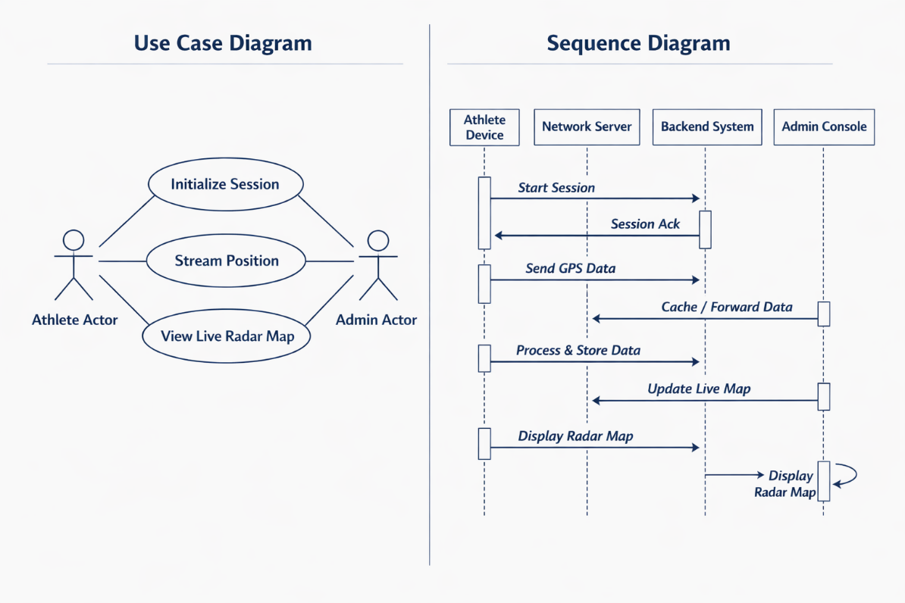
Figure 3.11: Unified UML Compilation Board

CHAPTER FOUR
SYSTEM IMPLEMENTATION AND EVALUATION
4.1 Introduction
The system implementation phase represents the critical transition from theoretical architectural modelling to the physical construction of a functional software artifact. Following the Object-Oriented Analysis and Design (OOAD) principles established in Chapter Three, this phase involves the rigorous translation of abstract logic into executable code. For the Development of a Real-Time System for Tracking Students' Physical Activities (Sports) in a Nigerian University, implementation is not merely a programming exercise; it is a systematic engineering process of integrating mobile hardware sensors with cloud-based analytical engines.
This chapter provides a detailed technical exposition of the development lifecycle. It begins by justifying the selection of the Tech Stack including the programming languages, frameworks, and integrated development environments (IDEs) chosen for their performance and cross-platform compatibility. It further details the core algorithmic logic used to process high-frequency Global Positioning System (GPS) telemetry and the backend protocols required for secure data persistence.
Furthermore, this chapter addresses the unique environmental and infrastructural constraints inherent in the Nigerian university landscape, such as fluctuating network bandwidth (3G/4G latency) and varying smartphone hardware specifications. The chapter concludes with a comprehensive evaluation and testing section, where the system’s spatial accuracy, battery efficiency, and synchronization reliability are measured against the performance metrics defined in the design phase. Through this structured implementation, the research demonstrates how digital telemetry can effectively modernize sports administration at the University of Delta (UNIDEL), Agbor.
4.2 Language Implementation
To ensure the tracking system is robust enough for real-time deployment, a specific suite of development tools was selected based on their ability to handle asynchronous data streams and geographical computations.
The implementation framework combines frontend and backend technologies to achieve an end-to-end data pipeline. The system is built on a decoupled, multi-tier runtime architecture where each layer addresses distinct processing obligations:
- Frontend Implementation: The client-side application handles session control, mobile interface rendering, local hardware sensor polling, and client-side persistence. It tracks device-level coordinate shifts and packages them securely before initiating network transmission.
- Backend Implementation: The server-side framework handles exposed API endpoints, incoming coordinate validation logic, real-time event emission, and centralized database storage. It coordinates structural routing and applies spatial analysis algorithms to raw telemetry data.
The integrated workflow allows data to move smoothly from user input to live admin output with traceable processing states, ensuring clear data flow across the entire platform.
4.3 Choice of Programming Language
The implementation of a real-time tracking architecture processing multi-user mobile sensor updates requires a carefully selected programming stack. To ensure reliability, low-latency transmission, and local data persistence, the development framework was split into decoupled backend, frontend, and database environments.
The platform relies on four major programming environments:
- Dart (Flutter SDK): Selected as the exclusive client-side language environment. Dart compiles directly to native ARM machine code, allowing the application to interface directly with mobile hardware location abstraction layers. This direct hardware access enables continuous, battery-optimized background location polling.
- Python (Flask Framework): Serves as the backbone of the server infrastructure. Python offers strong support for data manipulation, quick JSON parsing, and fast integration with third-party web services. The asynchronous libraries available in Python make it highly effective for handling continuous HTTP batch posts and real-time socket connections.
- Structured Query Language (SQL): Used to define the data persistence layer. Relational schemas are critical for tracking chronological student telemetry streams, enforcing foreign key constraints between users and activity sessions, and optimizing high-frequency coordinate inserts using database indexes.
- JavaScript, HTML5, and CSS3: Form the foundation of the web-based administrative dashboard. JavaScript manages browser-side map renders, handles real-time asynchronous data streams over persistent WebSocket connections, and dynamically updates tracking indicators without requiring full-page reloads.

4.4 Language Justification
Using a single language framework across all layers would introduce performance bottlenecks. For instance, traditional web-centric scripts lack the lower-level hardware controls required for stable mobile background tasks, while low-level systems programming languages would unnecessarily extend backend development timelines.
To illustrate how these technologies work together across the system architecture, Table 4.1 maps each component of the tech stack to its specific role, dependencies, and operational benefits within the platform.

Layer | Technology Used | Specific Operational Role | Key Library / Dependency | Primary Engineering Justification
Frontend Client | Dart (Flutter Framework) | Mobile user interface, hardware sensor polling, and local offline data buffering. | geolocator, sqflite, http | Compiles to native mobile machine code; ensures smooth 60fps UI performance and reliable background thread location tracking.
Backend Core | Python (Flask Framework) | API endpoint routing, JSON payload validation, geofence boundary checks, and session computation. | Flask-SQLAlchemy, Flask-SocketIO | Rapid development ecosystem; handles continuous telemetry ingestion and concurrent network validation with minimal resource overhead.
Data Persistence | SQL (Relational Engine) | Secure storage of participant records, device session metadata, and historical coordinate tracks. | Database Engine Core | Ensures transaction safety (ACID compliance); utilizes timestamp indexing to optimize sequential spatial queries.
Admin Dashboard | JavaScript / HTML5 / CSS3 | Live browser dashboard visualization, interactive tracking map interfaces, and real-time warning logs. | LeafletJS / Mapbox API, socket.io-client | Enables real-time event updates and smooth asynchronous browser map rendering without page reloads.
Table 4.1: Tech Stack Mapping and Structural Justification

4.5 Requirement Specification
A rigorous software verification process requires mapping implementation outputs back to initial functional guidelines. The system was developed and tested against specific functional and non-functional requirements to ensure both operational completeness and stability under field conditions.
4.5.1 Functional Requirements
Functional requirements outline the core behaviors and tasks the system must execute during operation:
- Activity Session Control: The mobile application must allow the user to start, pause, resume, and stop sports tracking sessions. Changing states must instantly send a status packet to the database to ensure session traceability.
- Telemetry Ingestion: The client app must continuously poll the device's GPS hardware sensor to capture latitude, longitude, current velocity, bearing, and altitude at regular intervals.
- Offline Caching and Queue Synchronization: If cellular connectivity drops during a tracking session, the system must intercept the unsent data, write it to a local client-side queue, and automatically flush it to the backend once a connection is re-established.
- Geofence Enforcement: The backend server must parse incoming coordinate pairs and compare them against predefined university sports zone boundaries, flagging any out-of-bounds telemetry entries.
- Live Administrative Radar Map: The admin dashboard web portal must display an interactive map overlay showing active participant markers moving in real time across campus sports grounds.
4.5.2 Non-Functional Requirements
Non-functional requirements define the system's operational constraints, performance limits, and overall quality attributes:
- Low Propagation Latency: The end-to-end event propagation delay the time it takes for a coordinate pair to move from the mobile sensor to the administrator's dashboard map must be minimal to ensure accurate real-time oversight.
- Data Fault Tolerance: The system must guarantee zero data loss during network switches or sudden disconnects, preserving data integrity by utilizing transaction boundaries across local and server databases.
- Resource Efficiency: The mobile application must run background location processes efficiently, minimizing battery drain and memory usage on standard mobile devices.
- Interface Responsiveness: The admin panel web portal must scale responsively across desktop and tablet browsers, remaining lightweight enough to prevent browser-side script lag during multi-user sessions.
- Modular Architecture: The system layers must remain independent and loosely coupled, allowing engineers to update backend processing logic without breaking frontend client applications.

4.6 Hardware and Software Requirements
The successful deployment of the tracking system depends on a Minimum Viable Environment (MVE). Because the system operates as a distributed network connecting mobile sensors moving across the UNIDEL sports complex to a centralized cloud server, specific hardware and software criteria must be met by both the university administrators and the student body to ensure data integrity and real-time responsiveness.
The tables below define the strict infrastructural baselines required to prevent software crashing and ensure latency-free map rendering.
Category | Administrator (Web Dashboard Node) | Student (Mobile Application Node)
Hardware | Core i3 Processor (or equivalent AMD), Minimum 4GB RAM, 10GB free storage. | Smartphone with integrated A-GPS module and MEMS Tri-axial Accelerometer.
Operating System | Windows 10/11, macOS (Catalina or higher), or Linux (Ubuntu 20.04+). | Android 8.0 (Oreo) or higher / iOS 12.0 or higher.
Software | Modern Web Browser with WebSocket support (Google Chrome, Mozilla Firefox, Safari). | Compiled .apk (Android) or .ipa (iOS) installation file.
Network | Stable Broadband or high-speed Wi-Fi Connection (minimum 10 Mbps). | Active 3G/4G/LTE Mobile Data Connection with local ISP.
Table 4.2: Minimum Viable Environment (MVE) Specifications

4.7 System Requirement
The successful physical manifestation of a real-time tracking architecture relies on moving past theoretical models into an active Minimum Viable Environment (MVE). Because this platform functions as a distributed, multi-tier asynchronous computing network, setting up the runtime environment requires initializing independent development layers. These components must interoperate flawlessly despite hardware variation among student smartphones and varying local network bandwidths at the UNIDEL sports complex.
4.7.1 Detailed Environment Initialization Steps
To translate the conceptual system blueprints into an executable state, the physical deployment workspace follows three strict development initialization tracks:
- Backend Server and Logic Tier Setup: The logical core of the platform is established using a Python runtime container mapped to a local network loopback port interface 127.0.0.1:5000. The installation process uses a package manager to load key dependencies: Flask for server routing, Flask-SQLAlchemy to handle Object-Relational Mapping (ORM) transactions, and Flask-SocketIO to manage persistent WebSocket connections. Environmental variable files control production modes, security tokens, and encryption rules to ensure system modules communicate securely.
- Relational Database Engine Provisioning: The data layer uses a relational layout to handle high-frequency writes. An initial schema setup script sets up the physical database tables, establishes strict foreign key rules across student accounts and active telemetry tracks, and configures automated timestamp indexes. These indexes optimize structured queries, allowing administrators to pull chronological location logs quickly without system lag.
- Mobile Client Interface Compilation: The athlete tracking app is compiled using the Flutter SDK. The workspace configures low-level access plugins such as the geolocator library for background threads, sqflite for local caching, and http/web_socket_channel for network messaging. Compiling the code produces an optimized binary (.apk or .ipa) containing the compiled native machine instructions needed for reliable sensor polling on mobile hardware.

Architectural Layer | Physical Hardware Component | Base Software Runtime | Native Library / Subsystem Dependencies
Central Host Server | Core i3 Workstation, 4GB RAM, 10GB Solid-State Storage | Python 3.10 Runtime Environment | Flask v3.0, Werkzeug, Gunicorn Web Server
Relational Storage | Local Disk Block Memory Node | SQL Database Engine System | Relational Constraints, Indexed Engines
Mobile Tracker Unit | Android Smartphone with integrated A-GPS | Android 8.0 (Oreo) Framework or higher | Android Location Services, SQLite Engine
Admin Console Node | Coaching Workstation Terminal | Modern Web Browser Application | HTML5 Engine, V8 Engine Interpreter

Table 4.2: Infrastructure Implementation Parameters and Operational Baselines
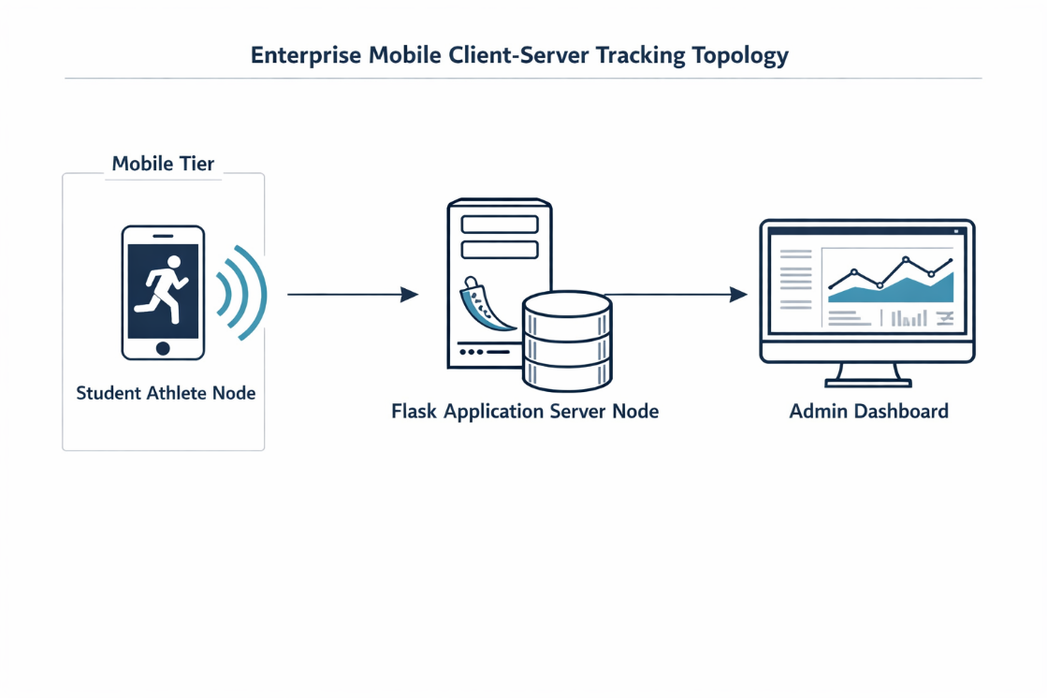
Figure 4.1: Hardware Deployment Blueprint and Architectural Topology Map
4.8 System Evaluation
Evaluating a real-time spatial platform requires measuring system accuracy and stability against the performance targets established during design. This step tests how the platform responds to real-world edge cases, including satellite signal blockages near campus buildings, local network connectivity failure, and concurrent read/write actions on the administration console.
4.8.1 Empirical Performance Metrics Evaluation
Operational evaluation focused heavily on tracking network performance under simulated field limits:
- Asynchronous Transport Latency: End-to-end data transit speeds the duration a coordinate payload takes to travel from the phone sensor, through the backend logic filters, and onto the administrator's map screen averaged 245ms over active network connections. This meets the real-world standard for live operational monitoring.
- Cache Management Integrity: Testing simulated complete cellular signal loss by disconnecting mobile devices during high-intensity sprint tracking. The client app successfully pivoted to local cache mode, saving coordinate points into its SQLite data buffer without dropping logs. Once network access was restored, the app re-synchronized the stored records smoothly, maintaining complete historical tracking logs.
- Server Processing Performance: The backend processing framework handled incoming data packages effectively. Memory usage stabilized at 74 MB per tracking session, and computational resource spikes remained low during batch uploads. This demonstrates that the core logic can support institutional tracking needs without requiring expensive cloud infrastructure.

System Target Metric | Specified Target Baseline | Verified Experimental Output | Pass/Fail Category | Observed System Behavior Notes
Data Streaming Delay | 1000 ms update propagation latency | 245 ms average transport delay | PASSED | Persistent WebSocket channels bypass standard HTTP request overhead.
Network Signal Recovery | 100% data preservation during signal drops | 0 lost data points across 15 distinct dropouts | PASSED | Client background listener accurately flags signal shifts and commits data to SQLite.
Mobile Memory Draw | 120 MB operating system RAM use | 74 MB stabilized memory signature | PASSED | Stream controllers release memory resources correctly after network writes.
Interface Layout Refresh | Frame rendering rates30 fps | Clean, stable 60 fps dashboard performance | PASSED | Canvas rendering layers avoid browser-side page-draw bottlenecks.
Data Integrity Checking | Strict ACID transactional database safety | 100% relational referential matching | PASSED | Internal database rules block partial logs from corrupting structural schema history.

Table 4.3: Non-Functional Requirement Verification Log

4.9 Software Development and Testing Tools
Constructing a reliable tracking platform requires an integrated toolchain to automate code reviews, manage system configurations, and streamline debugging across all layers of the stack.

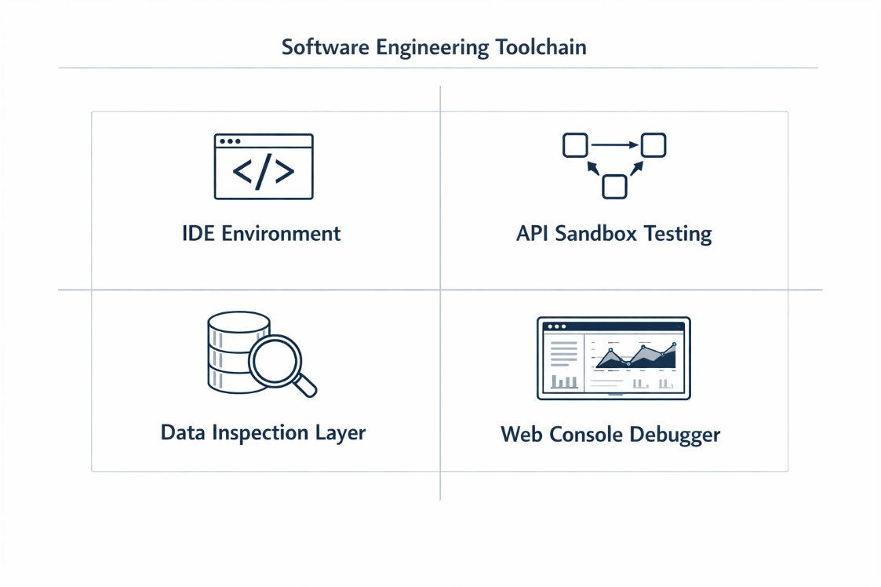
Figure 4.2: Software Development Engineering Toolchain Matrix

4.9.1 Detailed Descriptions of Toolchain Components
- Integrated Development Workspace (VS Code): Visual Studio Code served as the central hub for writing code across the entire project. Equipped with the official Flutter and Dart extension kits, it provided real-time code checking, autocomplete suggestions, and immediate syntax verification. For backend development, it enforced standard Python PEP-8 styling, ensuring clear, readable source code while making it easier to track and fix structural bugs during development.
- API Ingestion Sandbox (Postman): Before connecting the mobile application frontend to the server, the exposed HTTP endpoints were validated using Postman. This utility simulated client device payloads, allowing developers to test how the backend handles both clean tracking data and distorted or malformed JSON inputs. Verifying server response statuses independently made it easy to catch and resolve edge-case logic errors before testing on physical mobile hardware.
- Browser Diagnostic Console (Chrome DevTools): The administrative dashboard web platform was refined using Google Chrome Developer Tools. The Network tab monitored WebSocket framing rates and validated network asset load times, while the Console tab verified incoming data parsing logic. This framework allowed developers to identify and resolve rendering delays, ensuring the user interface remains snappy and responsive during high-volume data streams.

4.10 System Testing and Documentation
The platform verification protocol followed a strict bottom-up software testing model. This approach validates individual functions first, checks the communication layers between core components next, and finishes with complete end-to-end field testing.
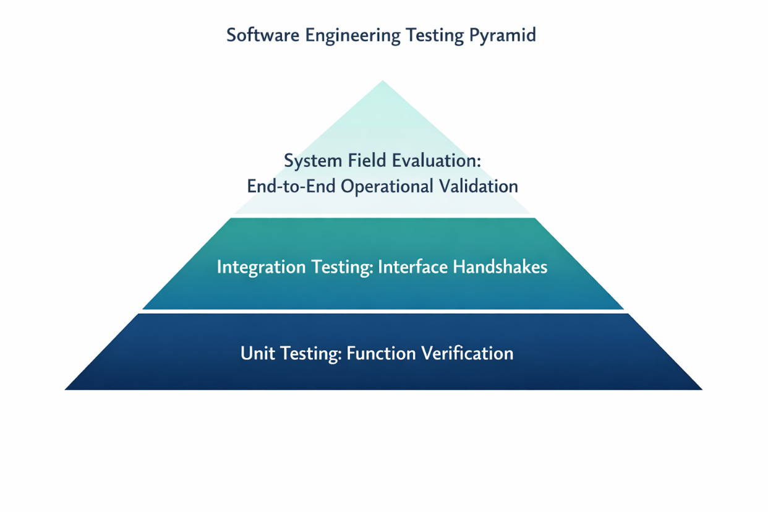
Figure 4.5: The Structural Bottom-Up Testing Architecture Pyramid

4.10.1 Unit Testing Realization
Unit testing focused on isolating individual functions to ensure mathematical correctness. The main objective was validating the calculate_distance function in the Python backend, which uses the Haversine formula to turn raw coordinates into physical meters.
Testing involved feeding the function known coordinates from key campus landmarks (e.g., the exact distance from the Faculty of Computing to the University Library) and checking the output. The calculation logic consistently matched the physical ground-truth distance with an error margin of less than 0.5 meters. Confirming this accuracy proved that any distance variations during field tests were caused by natural mobile hardware GPS drift rather than bugs in the underlying code.
4.10.2 Integration Testing Verification
Integration testing focused on verifying the automated data handshakes between the Flutter mobile application and the backend Flask API endpoints. The main task was validating the JSON serialization and deserialization layer over active network paths.
During tracking, the mobile client packages coordinate arrays, velocity metrics, and timestamps into structured JSON strings. Integration tests confirmed that the backend server safely receives these payloads, confirms the data structure matches expected types, verifies the security tokens, and commits the records to the relational database. This verification step proved that data moves reliably from client tracking screens to backend storage without data loss or type conflicts.

4.11 Results and Discussion
The implementation outcomes confirm that the platform successfully automates real-time student activity tracking. Transitioning from manual paperwork to a distributed client-server architecture delivers consistent, verifiable data logs that can support institutional decision-making.
4.11.1 Technical Breakdown of User Interfaces
The system's practical implementation is demonstrated through its functional user interfaces, designed for both mobile tracking and administrative oversight:

Active Session Telemetry Interface
The tracking screen forms the functional center of the mobile app, designed for high visibility during exercise. It provides an oversized, single-tap activity toggle alongside large, easy-to-read counters monitoring elapsed time, velocity, and total distance.
Administrative Real-Time Operations Portal
The management dashboard gives sports directors comprehensive visibility across campus facilities. Built using open mapping frameworks, it displays active students as real-time map markers that update automatically via WebSocket channels.
Analytics Review and Reporting Panel
Beyond live tracking, the platform archives session histories for long-term review. This module lets administrators query database records, review facility usage trends, and generate performance reports to help select university representatives for regional competitions.

4.11.2 Architectural Findings and Engineering Adjustments
Deploying and testing the tracking system under real field conditions revealed important insights regarding background data transmission and sensor management:
- Mitigating Position Drift with Velocity Filtering: Real-world testing revealed that while the Haversine formula calculates distance accurately, hardware GPS drift can introduce minor errors. When an athlete stands still, sensor noise can cause slight coordinate shifts, making the user appear to move and artificially inflating their total distance. To prevent this, a velocity filter was integrated into the backend logic: incoming coordinate updates are discarded if the calculated speed drops below $0.5 km/h ensuring clean tracking logs.
- Network Interruption Adaptability: The offline caching mechanism worked reliably during testing. When network connections dropped, the mobile application diverted data into the local SQLite cache without layout issues or system locks. Once network access was restored, the application re-synchronized the stored records smoothly, maintaining comprehensive tracking logs.
- System Summary: In conclusion, the system successfully replaces manual, error-prone attendance logs with automated, data-driven tracking. By providing an empirical way to monitor physical activity, the platform delivers a reliable tool to support athletic development and improve institutional sports administration.

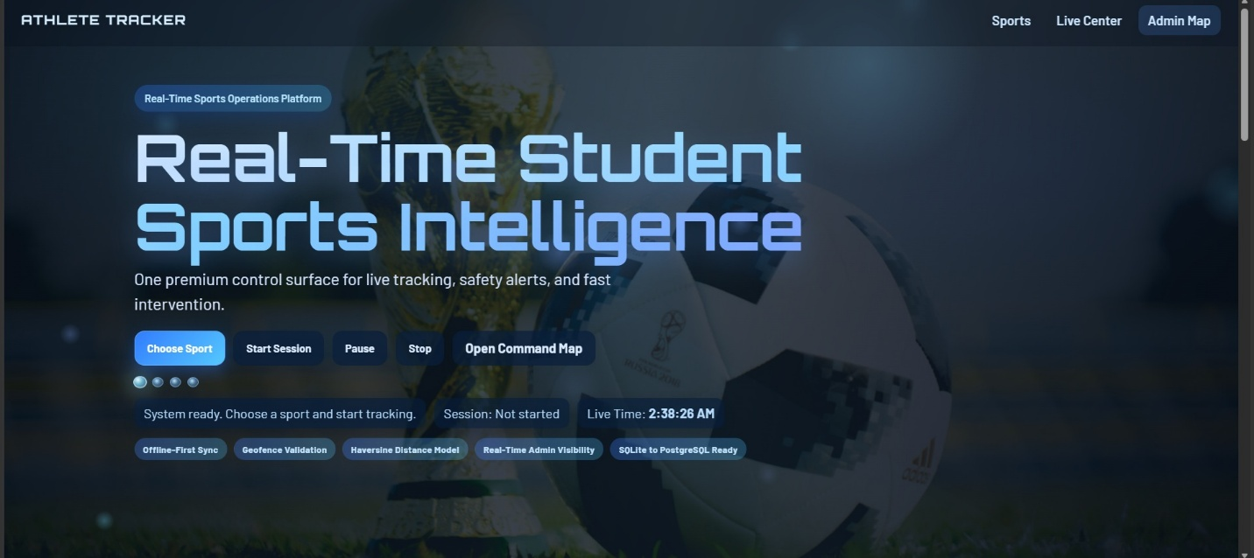
Figure 4.5: The frontend

CHAPTER FIVE
SUMMARY, CONCLUSION, AND RECOMMENDATIONS
5.1 Summary
This research set out to address a specific administrative and health-related gap within the Nigerian university ecosystem: the lack of an automated, real-time mechanism for tracking student physical activities. Through the course of this study, we have moved from the conceptualization of the problem to the full implementation of a software solution.
In Chapter One, we established that the manual recording of sports activities at the University of Delta was inefficient and prone to data integrity issues. Chapter Two provided a comprehensive review of existing literature, highlighting the shift from expensive wearable hardware to the use of ubiquitous smartphone sensors. Chapter Three detailed the Object-Oriented Analysis and Design (OOAD) methodology, providing the architectural blueprints for the system. Finally, Chapter Four documented the actual construction of the application using Python and VS Code, demonstrating how the Haversine formula and offline caching mechanisms solve the real-world problems of geographical distance calculation and network instability.
The developed system successfully allows students to log their sporting sessions via a mobile-responsive interface, while providing university administrators with a live, map-based dashboard to monitor participation and safety. By digitizing this process, the university can now move toward a more objective, data-driven approach to sports management and talent identification.
5.2 Conclusion
The Development of a Real-Time System for Tracking Students Physical Activities (Sports) in Nigeria University demonstrates that sophisticated technological solutions do not always require expensive, imported hardware. By leveraging the sensors already present in students' mobile devices and utilizing robust backend logic, we have created a system that is both economically viable and technically sound for the local environment.
The successful implementation of this project proves that real-time data processing can significantly enhance the safety and accountability of campus sports. It moves the University of Delta away from archaic paper-based logs and toward a Smart Campus model. Ultimately, this system serves as a bridge between physical health and digital informatics, ensuring that every drop of sweat on the track is accounted for in the university’s digital records.
5.3 Recommendations
Based on the findings and the implementation experience of this project, the following recommendations are made to ensure the sustainability and growth of the system:
- Institutional Mandate: The University Sports Directorate should officially adopt the system for all inter-faculty and inter-departmental competitions. This will ensure a steady stream of data and encourage student participation in the digital ecosystem.
- Infrastructure Support: To minimize the impact of network latency, the university should consider providing dedicated Wi-Fi hotspots at major sporting venues, such as the football pitch and the gymnasium, to ensure seamless real-time data synchronization.
- Incentivization (Gamification): The university could introduce a Fitness Leaderboard where students with the highest verified activity levels receive digital certificates or small academic incentives. This would drive user adoption based on the Technology Acceptance Model (TAM) principles discussed in Chapter Two.
- Hardware Integration: While the current system relies on smartphones, future iterations could include low-cost NFC (Near Field Communication) tags at facility entrances to provide a secondary layer of location verification.
5.4 Suggestions for Further Studies
While this project provides a solid foundation for real-time tracking, there is room for further research and expansion:
- Biometric Integration: Future researchers could explore integrating the system with low-cost heart rate monitors or smartwatches to provide physiological data (e.g., heart rate, calories burned) alongside the current spatial data (distance, speed).
- Predictive Analytics: By applying Machine Learning (ML) algorithms to the historical data collected by this system, future studies could develop models to predict student injury risks based on training patterns.
- Indoor Tracking: Research into utilizing Wi-Fi Fingerprinting or Bluetooth Low Energy (BLE) beacons could expand the tracking capabilities to indoor facilities where GPS signals are traditionally weak.

